No-Three-In-Line: AI-Guided Search
Oct 2, 2026 · @Amr

Summary
In its first 20 generations, the AI-guided search went from solving 2 of 6 benchmark sizes to all 6 (n = 10 to 30), at an API cost of about $3.50. The best program now finds perfect 2n-point solutions up to n = 32. All of these sizes already have known solutions, so this is not yet new mathematics; the smallest sizes reported as open are around n = 71 and 73.
The project lives in D:\Three points. It has three parts: an exact verifier, hand-written search programs, and a loop in which Claude Opus 5.5 rewrites the best program and every result is re-verified. The next step is a harder benchmark (n = 32 to 42), followed by speed-ups that make larger n realistic.

The problem
The goal is to place as many points as possible on an n × n grid so that no three points lie on one straight line, at any slope. The question has been open since Henry Dudeney's 1917 puzzle book.
Why 2n is the maximum. Each row is a straight line, so a row can hold at most two points. With n rows, that caps the total at 2n. A perfect solution therefore has exactly two points in every row and, for the same reason, every column.
What is still unknown. Nobody knows whether 2n is reachable for every n. Richard Guy and Patrick Kelly conjectured that for very large n the answer drops to about 1.814n, so perfect solutions would eventually stop existing.
Known records (checked 2026-10-01):
- OEIS A000769 lists perfect 2n solutions for every n up to 60.
- A 2026 project, no3inline-rigidity, reports solutions for every n up to 70, plus 72 and 74. That would leave n = 71 and 73 as the smallest open cases. These still need checking against Achim Flammenkamp's record database before we rely on them.
Two things make this a good target for a computer search. Any proposed solution can be checked exactly in a fraction of a second. And progress is measurable: either 2n points are found for a given n, or they are not.

Our approach
We built a small version of Google DeepMind's FunSearch and AlphaEvolve: the AI does not solve the problem directly, it writes search programs, and the best programs are improved over many generations.
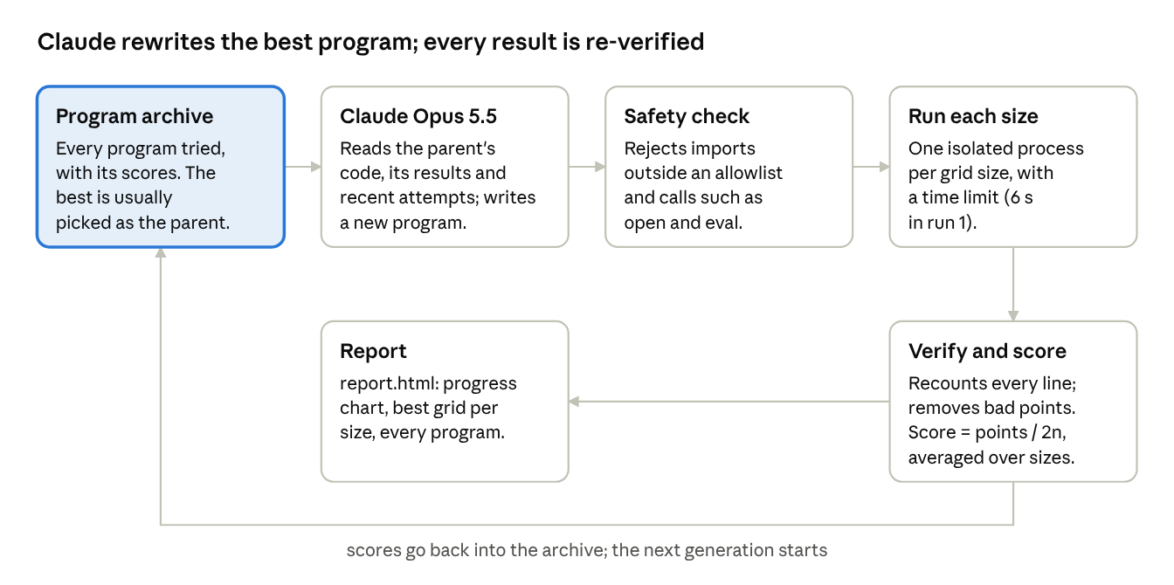
one generation of the evolution loop · no3/evolve.py
The AI never grades its own work. Every program follows one contract, construct(n, time_limit, seed), which returns a list of points. The evaluator then recounts every line itself and scores only what survives. Programs are ranked by how many sizes reach exactly 2n, then by average score.

Baselines
The hand-written baselines set the bar the AI had to beat: the best of them reached 2n only at n = 10. All runs used n = 10, 14, 18, 22, 26 and 30, with 6 seconds per size. The score is the average of points found ÷ 2n.
Program | How it works | Score | Sizes solved (2n)
Erdős construction | For a prime p, the points (x, x² mod p) never have three on a line. Uses the largest prime ≤ n. | 0.44 | 0 of 6
Random greedy | Adds grid points in random order, skipping any that would complete a line; keeps the best attempt. | 0.87 | 0 of 6
Simulated annealing | Starts with two points per row and column, then swaps columns between rows, accepting worse moves early on to escape dead ends. | 0.90 | 1 of 6 (n = 10)
The annealing program uses incremental bookkeeping: after a move it only recounts lines through the points that moved. Even so, pure Python manages only about 10,000–17,000 moves per second, which limits it on larger grids.

Symmetry-based search
Restricting the search to symmetric grids was the single biggest improvement: backtracking with symmetry solved n = 14 in about 2.5 seconds, while the same search without symmetry already failed at n = 12. Symmetric means the grid looks the same after a rotation or a mirror flip. Record solutions are mostly symmetric, and with a half-turn symmetry each choice places points in two rows at once, so there are far fewer combinations to try.
Symmetric backtracking fills rows from the outside in: choosing two columns for row y also fixes the mirror row n−1−y. Three rules keep it fast:
- Every placed point blocks every cell on a line through it and an earlier point, so a collinear triple can never form.
- The row with the fewest remaining options is filled next.
- A branch is abandoned as soon as any row or column can no longer get two points.
Attempts restart with a growing search budget, which avoids getting stuck in one bad branch. With 20 seconds per size, it solved every n from 10 to 16.
Symmetric annealing kept the annealing approach but only allowed moves that preserve the symmetry. It was no better than plain annealing (score 0.90, 1 of 6 solved). We checked that its cost tracking matches a full recount, so the limit is speed rather than a bug.
Lesson: annealing gets closest when it fails, but only backtracking reaches exact 2n solutions on bigger grids. Both programs became the starting point for the AI loop, which ranks programs by sizes solved first, then by score.

First evolution run
The first 20-generation run took the search from 2 of 6 sizes solved to all 6 by generation 6, for about $3.50 in API usage (102,000 input and 155,000 output tokens).
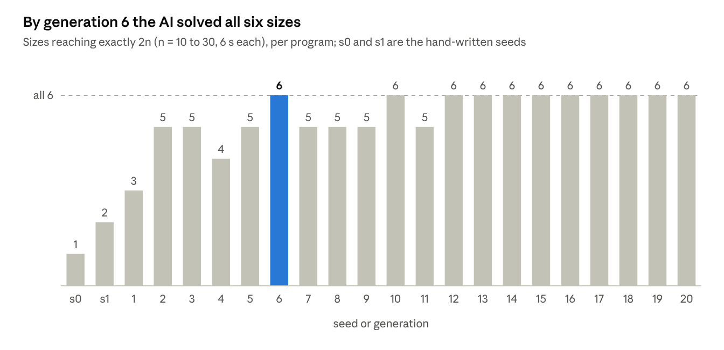
runs/20261001-215923/archive.json · 2 seeds + 20 generations, 2026-10-01
What the AI invented, in the generations that moved the result:
- Generation 1: added quarter-turn and diagonal-mirror symmetry for even n, and stored the grid as bitmasks for faster line checks.
- Generation 2: searched over whole symmetric groups of cells at once, so one lookup covers a full group instead of single points.
- Generation 5: rotated between quarter-turn, two-diagonal and half-turn symmetry, with a restart schedule taken from the research literature.
- Generation 6: added early checks that drop a branch as soon as a line can no longer be completed. This was the first program to solve all 6 sizes.
- Generations 10–20: kept that search and made it faster. The hardest size dropped from 2.7 s to 2.2 s (generation 12).
Stress test of the best program (generation 12, 60 s per size):
n | Points found | Target 2n | Result
32 | 64 | 64 | Solved in 52 s
36 | 64 | 72 | Not solved
40 | 64 | 80 | Not solved
44 | 72 | 88 | Not solved
48 | 76 | 96 | Not solved
52 | 80 | 104 | Not solved
This program's frontier is therefore around n = 32 to 34.

Status and next steps
The second run, on a harder benchmark of n = 32 to 42, is set up but has not started. The best program from run 1 (saved as programs/evolved_g012.py) solves 0 of these 6 sizes in 20 seconds each. The run stopped at its first Claude call because the API key was not set in the reopened terminal; nothing was charged.
- ☐ Set the API key and resume run 2 (about 30–40 minutes for 20 generations, roughly $3–5).
- ☐ Once progress slows, have the AI rewrite the best program for speed, for example with numba (likely 50–100× faster).
- ☐ Move long searches to a separate compute machine. The existing VPS hosts the live Inor app and should not carry heavy search jobs.
- ☐ Verify the reported open cases (n = 71, 73) against Flammenkamp's database before targeting them.
How to run (PowerShell, in D:\Three points):
$env:ANTHROPIC_API_KEY = "sk-ant-your-real-key"
python -m no3.evolve --resume "D:\Three points\runs\20261002-004836" --generations 20
The baselines run with python -m no3.baselines. Each run writes report.html into its folder under runs/, with a progress chart, the best grid for each size and every program tried.
Safety note: AI-generated code runs on this machine. A static check blocks unsafe imports and calls such as open and eval, and each program runs in a separate process with a time limit. That guards against accidents but is not a full sandbox.

